CONVERSIONS AND UNITS
Pearson Edexcel - Thursday 4 June 2020 - Paper 2 (Calculator) Foundation Tier

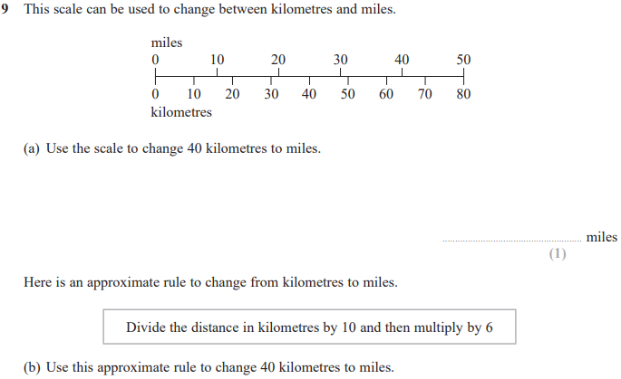
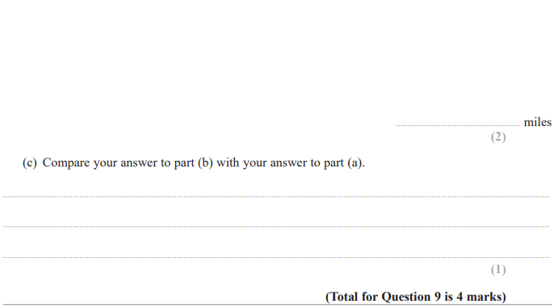

Pearson Edexcel - Monday 8 June 2020 - Paper 3 (Calculator) Foundation Tier

Pearson Edexcel - Thursday 6 June 2019 - Paper 2 (Calculator) Foundation Tier

Pearson Edexcel - Tuesday 11 June 2019 - Paper 3 (Calculator) Foundation Tier

Pearson Edexcel - Thursday 8 November 2018 - Paper 2 (Calculator) Foundation Tier

Pearson Edexcel - Thursday 7 June 2018 - Paper 2 (Calculator) Foundation Tier

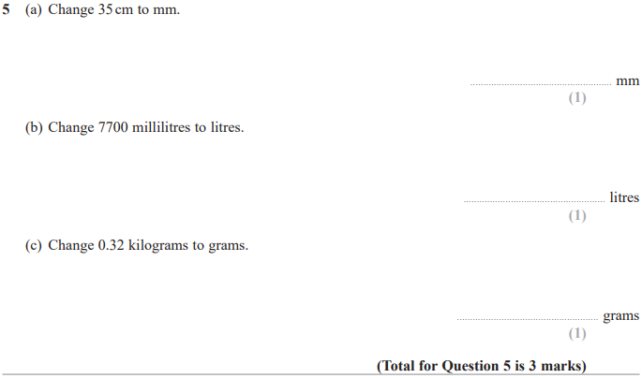

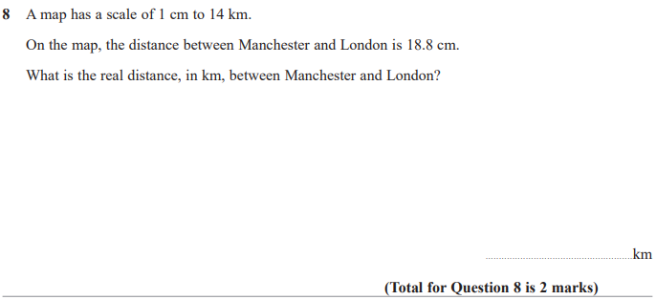

Pearson Edexcel - Thursday 2 November 2017 - Paper 1 (Non-Calculator) Foundation Tier

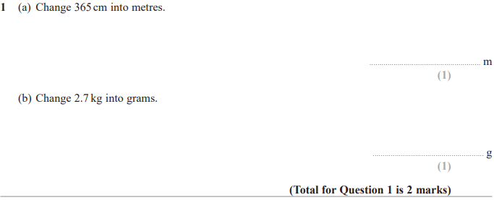

Pearson Edexcel – Specimen 2 - Paper 2 (Calculator) Foundation Tier

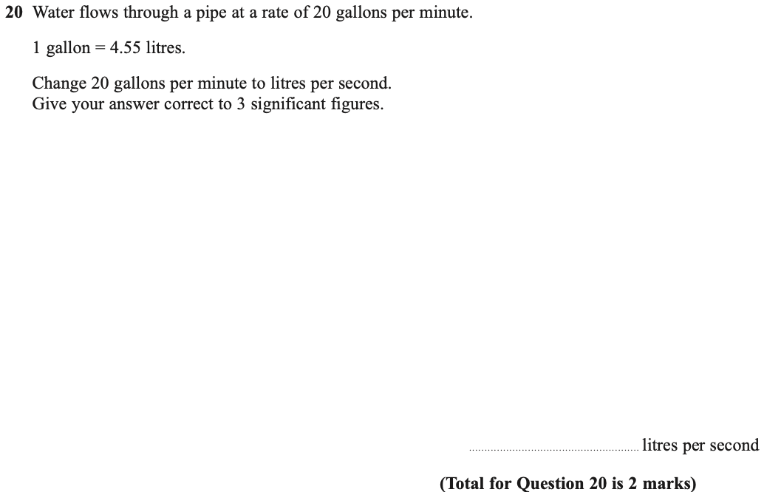

Pearson Edexcel – Specimen 2 - Paper 3 (Calculator) Foundation Tier

Pearson Edexcel – Specimen 1 - Paper 1 (Non-Calculator) Foundation Tier

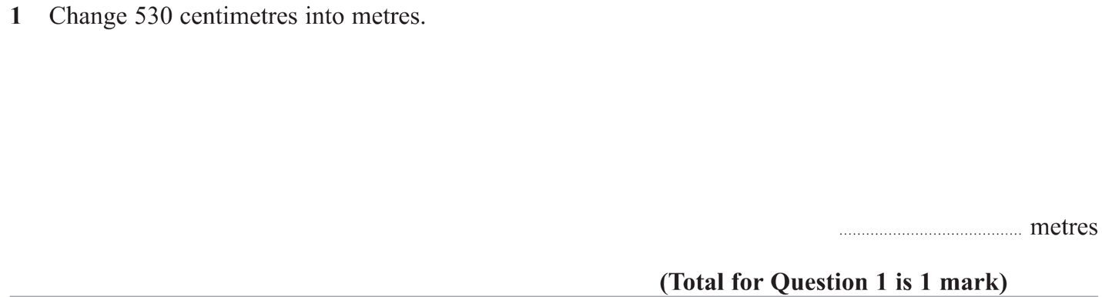

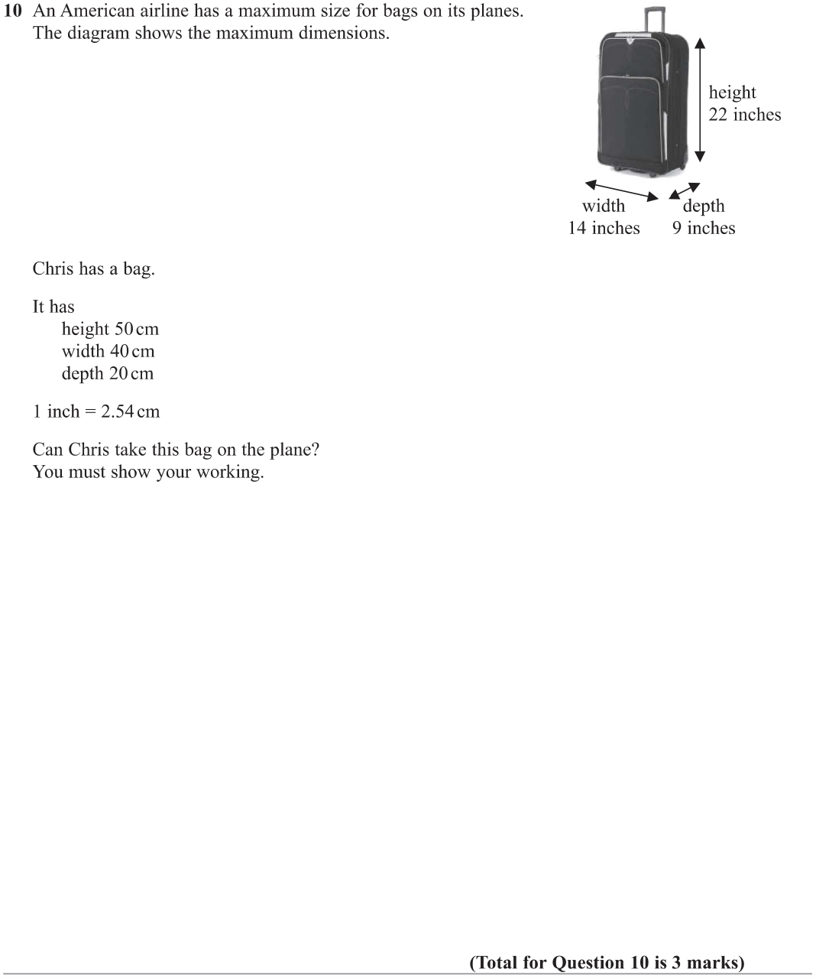

Pearson Edexcel – Specimen 1 - Paper 3 (Calculator) Foundation Tier

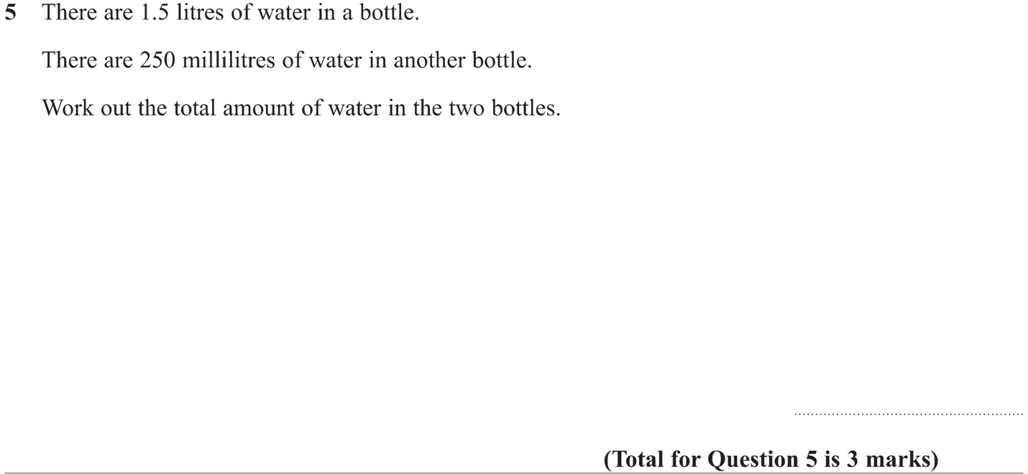

OCR Thursday 05 November 2020- Morning (Non-Calculator) Foundation Tier
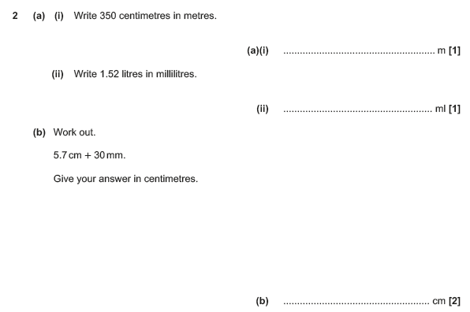

OCR Monday 11 November 2019 – Afternoon (Calculator) Foundation Tier
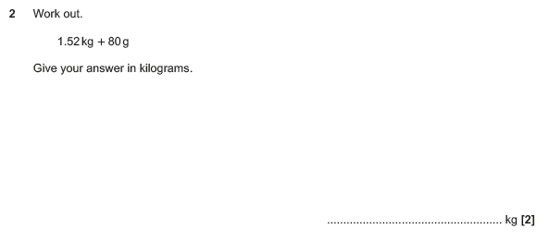

OCR Thursday 6 June 2019 – Morning (Non-Calculator) Foundation Tier
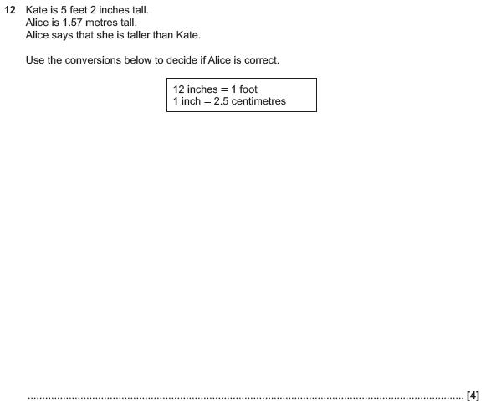

OCR Tuesday 11 June 2019 – Morning (Calculator) Foundation Tier
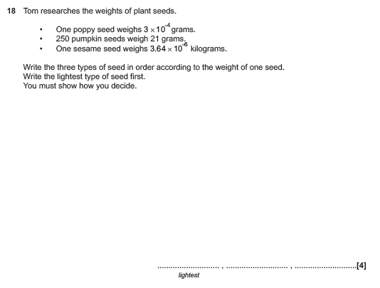

OCR Monday 6 November 2017– Morning (Calculator) Foundation Tier
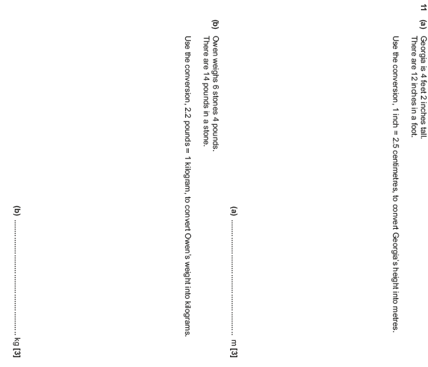

Pearson Edexcel – Sample Papers - Paper 3 (Calculator) Foundation Tier

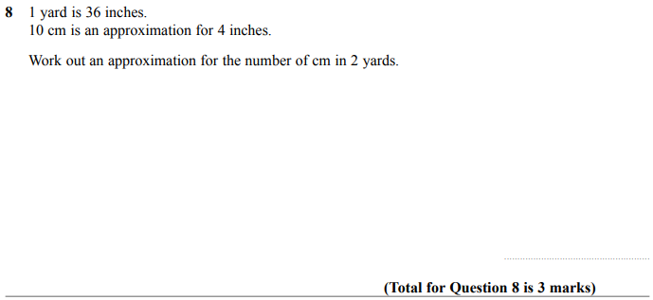

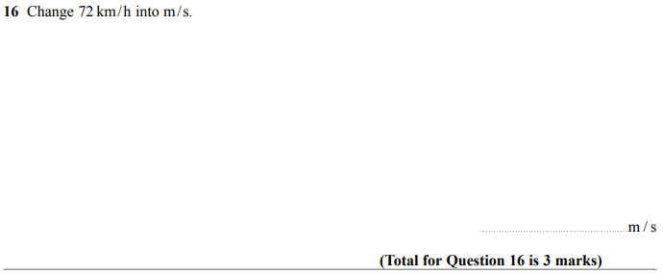

OCR Wednesday 8 November 2017– Morning (Calculator) Foundation Tier

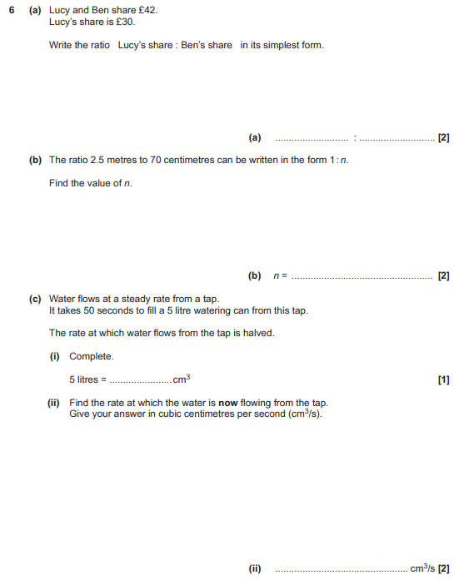

AQA Tuesday 19 May 2020 – Morning (Non-Calculator) Foundation Tier

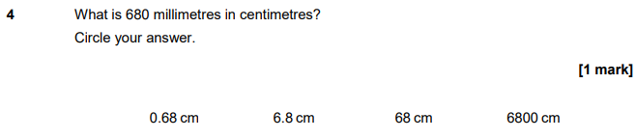

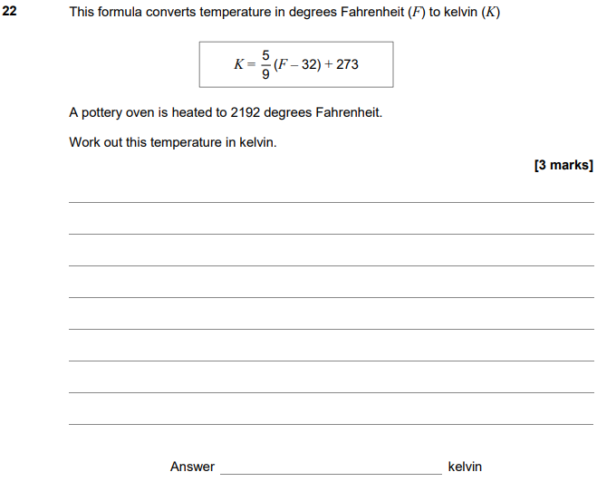

AQA Monday 8 June 2020 – Morning (Calculator) Foundation Tier

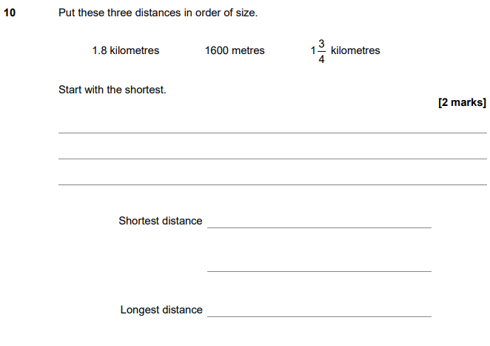

AQA Thursday 6 June 2019 – Morning (Calculator) Foundation Tier

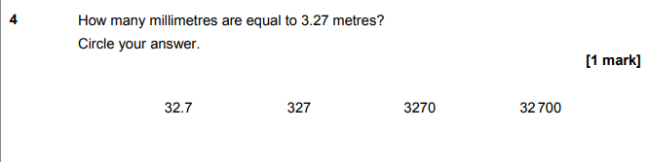

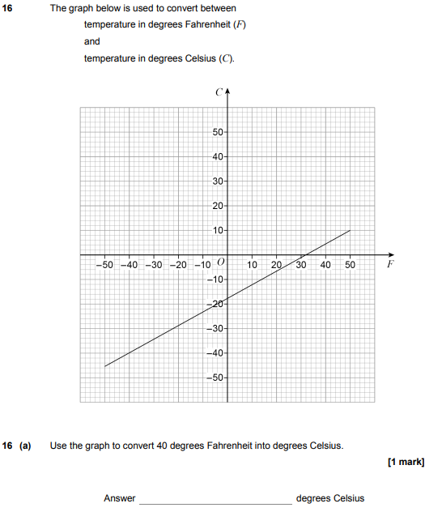
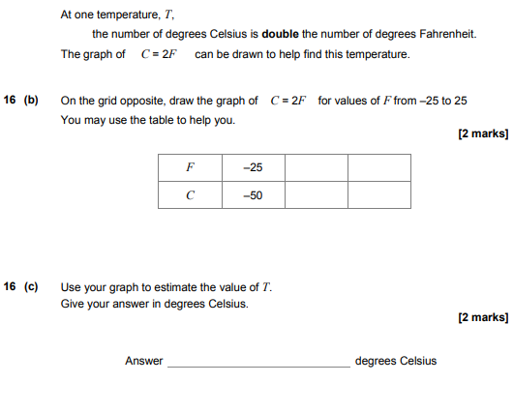

AQA Thursday 11 June 2019 – Morning (Calculator) Foundation Tier

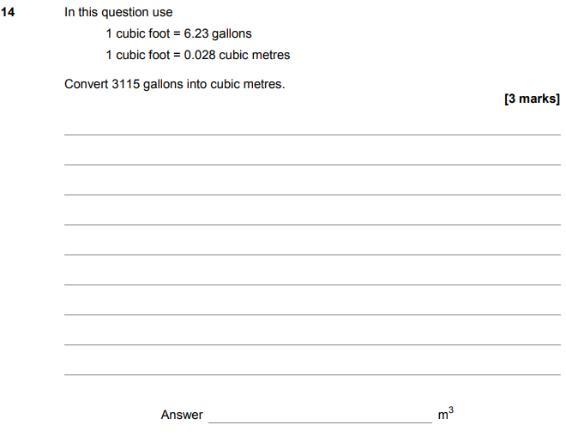

AQA Monday 12 November 2018 – Morning (Calculator) Foundation Tier

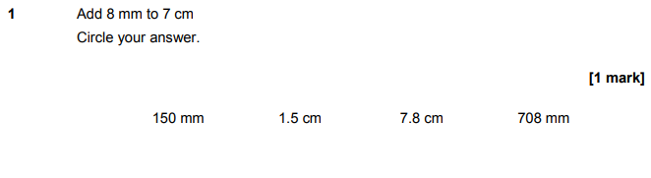
AQA Thursday 7 June 2018 – Morning (Calculator) Foundation Tier

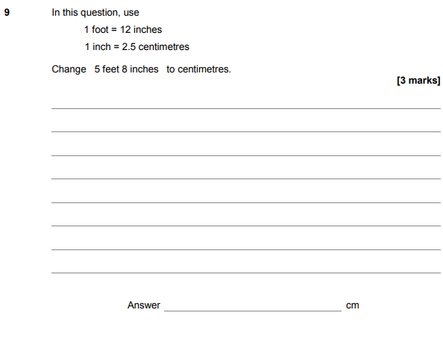

AQA Tuesday 12 June 2018 – Morning (Calculator) Foundation Tier

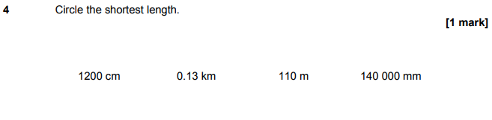
AQA Thursday 2 November 2017 – Morning (Non-Calculator) Foundation Tier

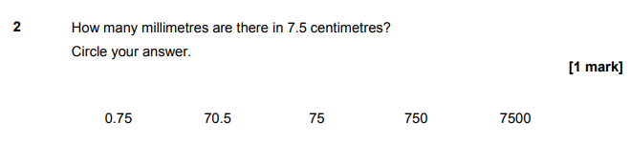
AQA Thursday 2 November 2017 – Morning (Non-Calculator) Foundation Tier

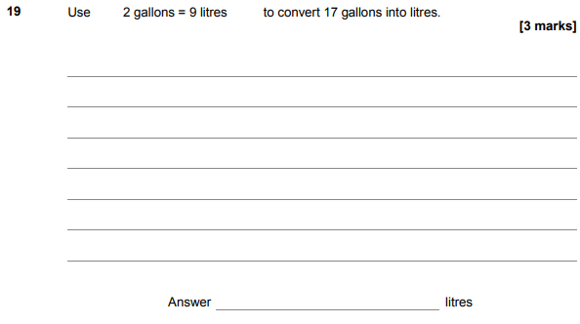
AQA Monday 6 November 2017 – Morning (Calculator) Foundation Tier

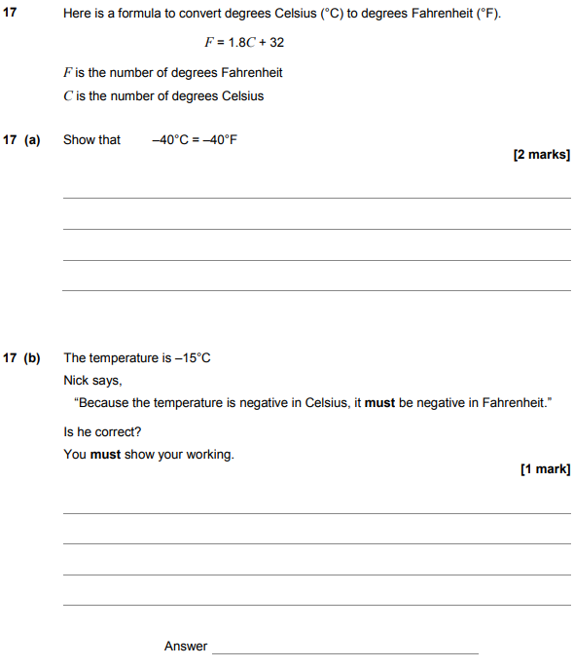

AQA Wednesday 8 November 2017 – Morning (Calculator) Foundation Tier

AQA Thursday 25 May 2017– Morning (Non-Calculator) Foundation Tier

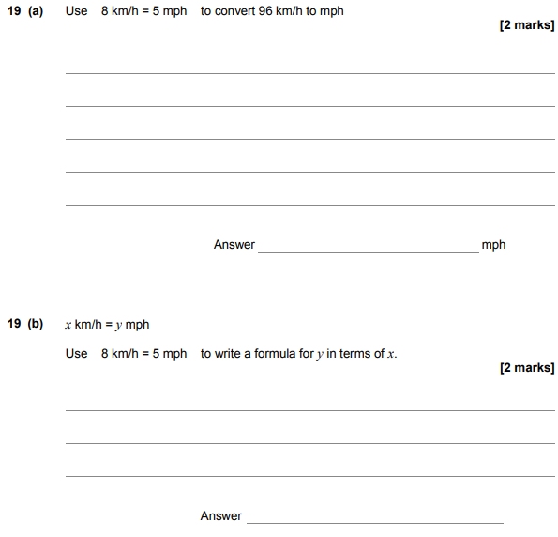
AQA Thursday 8 June 2017– Morning (Calculator) Foundation Tier

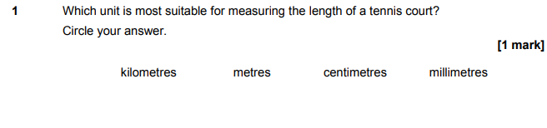
AQA Thursday 8 June 2017– Morning (Calculator) Foundation Tier

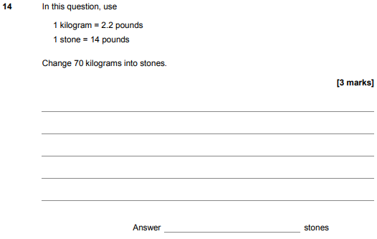

AQA Sample Paper 1– Morning (Non-Calculator) Foundation Tier

